**NCV2 Basic Principles of Computer Programming and Computer Literacy**

# Module 10: Modularisation and functions

**SUMMATIVE ASSESSMENT [Add this as question 8 of the summative assessment on page 264]**

8. Write a Python program to create a basic calculator using functions. The program must allow the user to enter two numbers from the keyboard and perform any of the following functions:

+ Addition

* + Subtraction

* Multiplication

/ Division

If the user input is not a number, the program must alert the user and show an error message such as: " The value entered was not a number". If the user makes an incorrect operator, the program must display an error message: "Invalid operator type entry".

Use try… except block to catch any errors.

Use the f string for displaying output.

**(20)**

**Add this as question 9 of the summative assessment on page**

**9.** The Osman’s Supply Store supplies different products to the public. Customers can buy different products on cash or on credit for their purchases. Customers who pay cash receive a discount, which is determined by the owner and differs from customer to customer. The discount should never exceed 25%. Design a Python program that will calculate the amount payable by customers for their purchases just like a point-of-sale. The program should allow user to enter the type of purchase by entering CS for Cash Sales or CR for Credit purchases. The program should allow the entry in any case ( lowercase or uppercase).

If the discount entered is greater than 25%, the program should display an error message. The program should also display the system's current date and time. The program must generate a receipt, which is displayed in a text file. The output sample of the text file should be as follows:

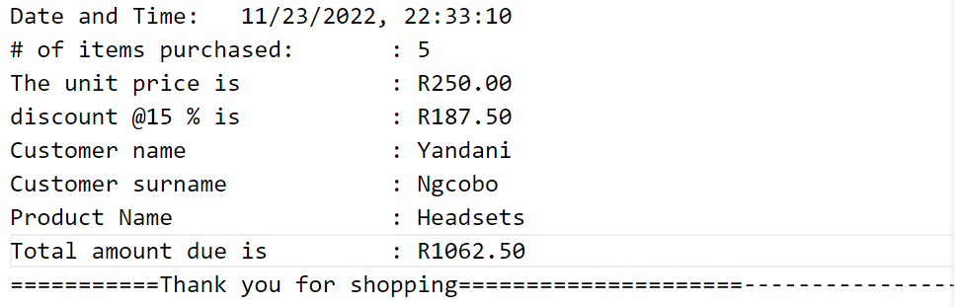

Below is an IPO-chart for the problem:

|  |  |  |
| --- | --- | --- |
| **INPUT** | **Processing** | **Output** |
| productid  productName  quantity  unitPrice  Credit Sales  CustomerName  CustomerSurname  Cash Sales:  CustomerID  CustomerName  CustomerSurname  discount | CreditSales:  amountPayable=quantity * unitPrice  CashSales:  amountPayable=quantity * unitPrice  discountt=amountPayable-discount/100 | CreditSales  Cash Sale  Quantity  unitPrice  customerName  customerSurname  Product Name  amountPayable  Cash Sale  Quantity  unitPrice  discount  customerName  customerSurname  Product Name  amountPayable |

**(25)**

**Total : 67 Marks**